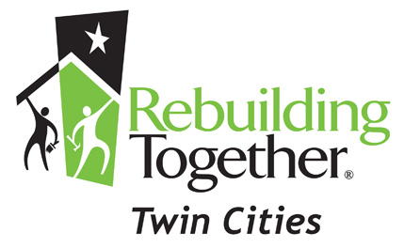
YOUR NAME HERE
YOUR ADDRESS: 123 Anystreet, Anycity, Minnesota 0000

Dear
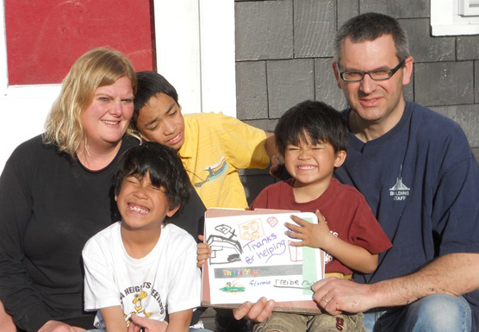
I'm writing to tell you about a cause I believe in and to ask for your help.
I Support Rebuilding Together Twin Cities. Rebuilding Together Twin Cities is a nonprofit housing organization that brings volunteers and communities together to improve the homes and lives of homeowners in need.
Rebuilding Together Twin Cities is awesome because they…
…Empower our Veterans. Every Year Rebuilding Together Twin Cities works to preserve affordable homeownership for those men and women have dedicated a part of their lives to protecting our freedom.
…Inspire Hope. Last year, Rebuilding Together Twin Cities completed much needed repairs for Peter and Colleen, and after the project they said, “I want to thank the volunteers for changing our outlook on life. A little over a year ago life seemed so difficult and impossible. The house was falling apart and medical situations were becoming difficult. Your group brought a new life to our home and gave us a new attitude.”
…Are Inclusive. Rebuilding Together Twin Cities partners with Veterans, Families with Children, Individuals with Disabilities, Older Adults without distinction such as race, color, sex, language, religion, political or other opinion, national or social origin, birth or other status.
…Preserve Affordable Homeownership. Rebuilding Together Twin Cities provides critical repairs and accessibility modifications for low-income homeowners, enabling them to remain in the homes and communities they love.
…Ensure Homeowners Can Maintain their Independence. After Rebuilding Together Twin Cities built a ramp at her home, Pat expressed it best when she said “I’m a handicap senior who lives in my childhood home. I’ve wished so deeply that I could roam (for me that means just getting outside). And wonderfully, it was not denied! For Rebuilding Together made that dream a wish come true!”
Can You Help? Please help me help this wonderful organization by making a $50 donation today. Your gift will ensure that homeowners like Pat can receive the repairs and accessibility modifications they need to stay in their homes. “We want to thank all of you at Rebuilding Together Twin Cities that were involved in the work that was completed at our home. From the very first call we made to you, you made us feel that we mattered! Thank you all!!”
Sincerely,
YOUR SIGNATURE HERE

P.S. My goal is to collect donations in the next 4 weeks. Your gift will help Rebuilding Together Twin Cities serve more local homeowners. Thank you.

