a Safe Space to
Play, Learn and Grow…Together

Dear

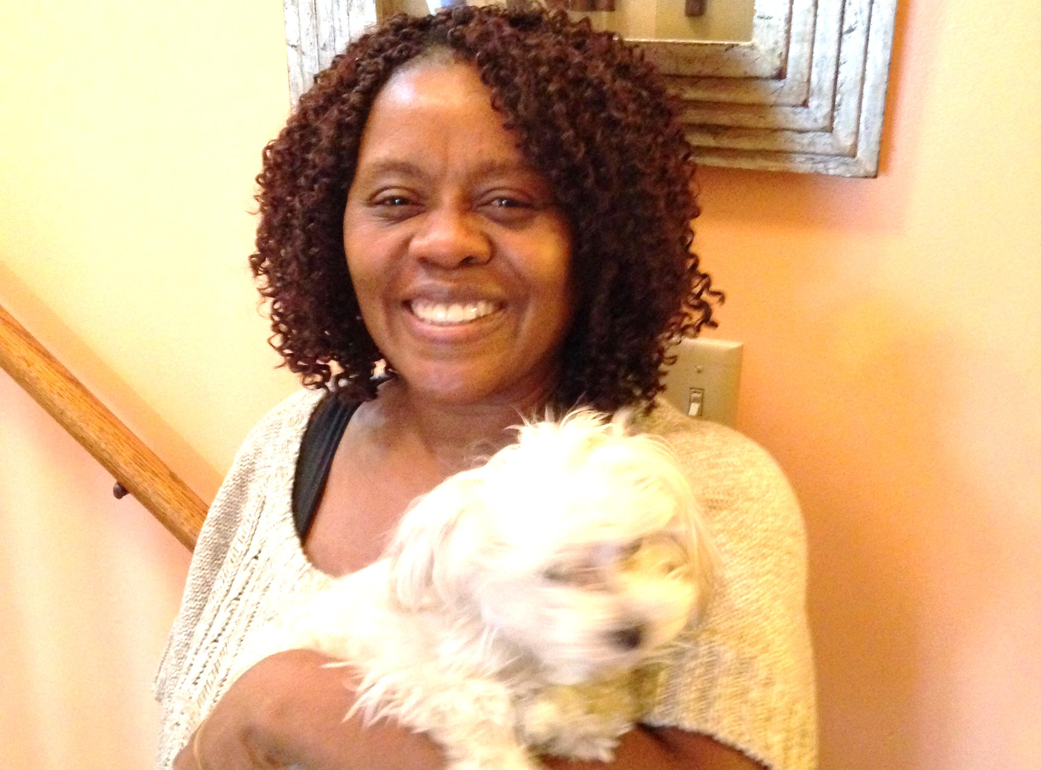
Last year I introduced you to (I want to introduce you to) an organization I care deeply about, Rebuilding Together Twin Cities. Every year, this organization helps to make home ownership affordable for hundreds of individuals throughout the Twin Cities, like Sano and Russel.

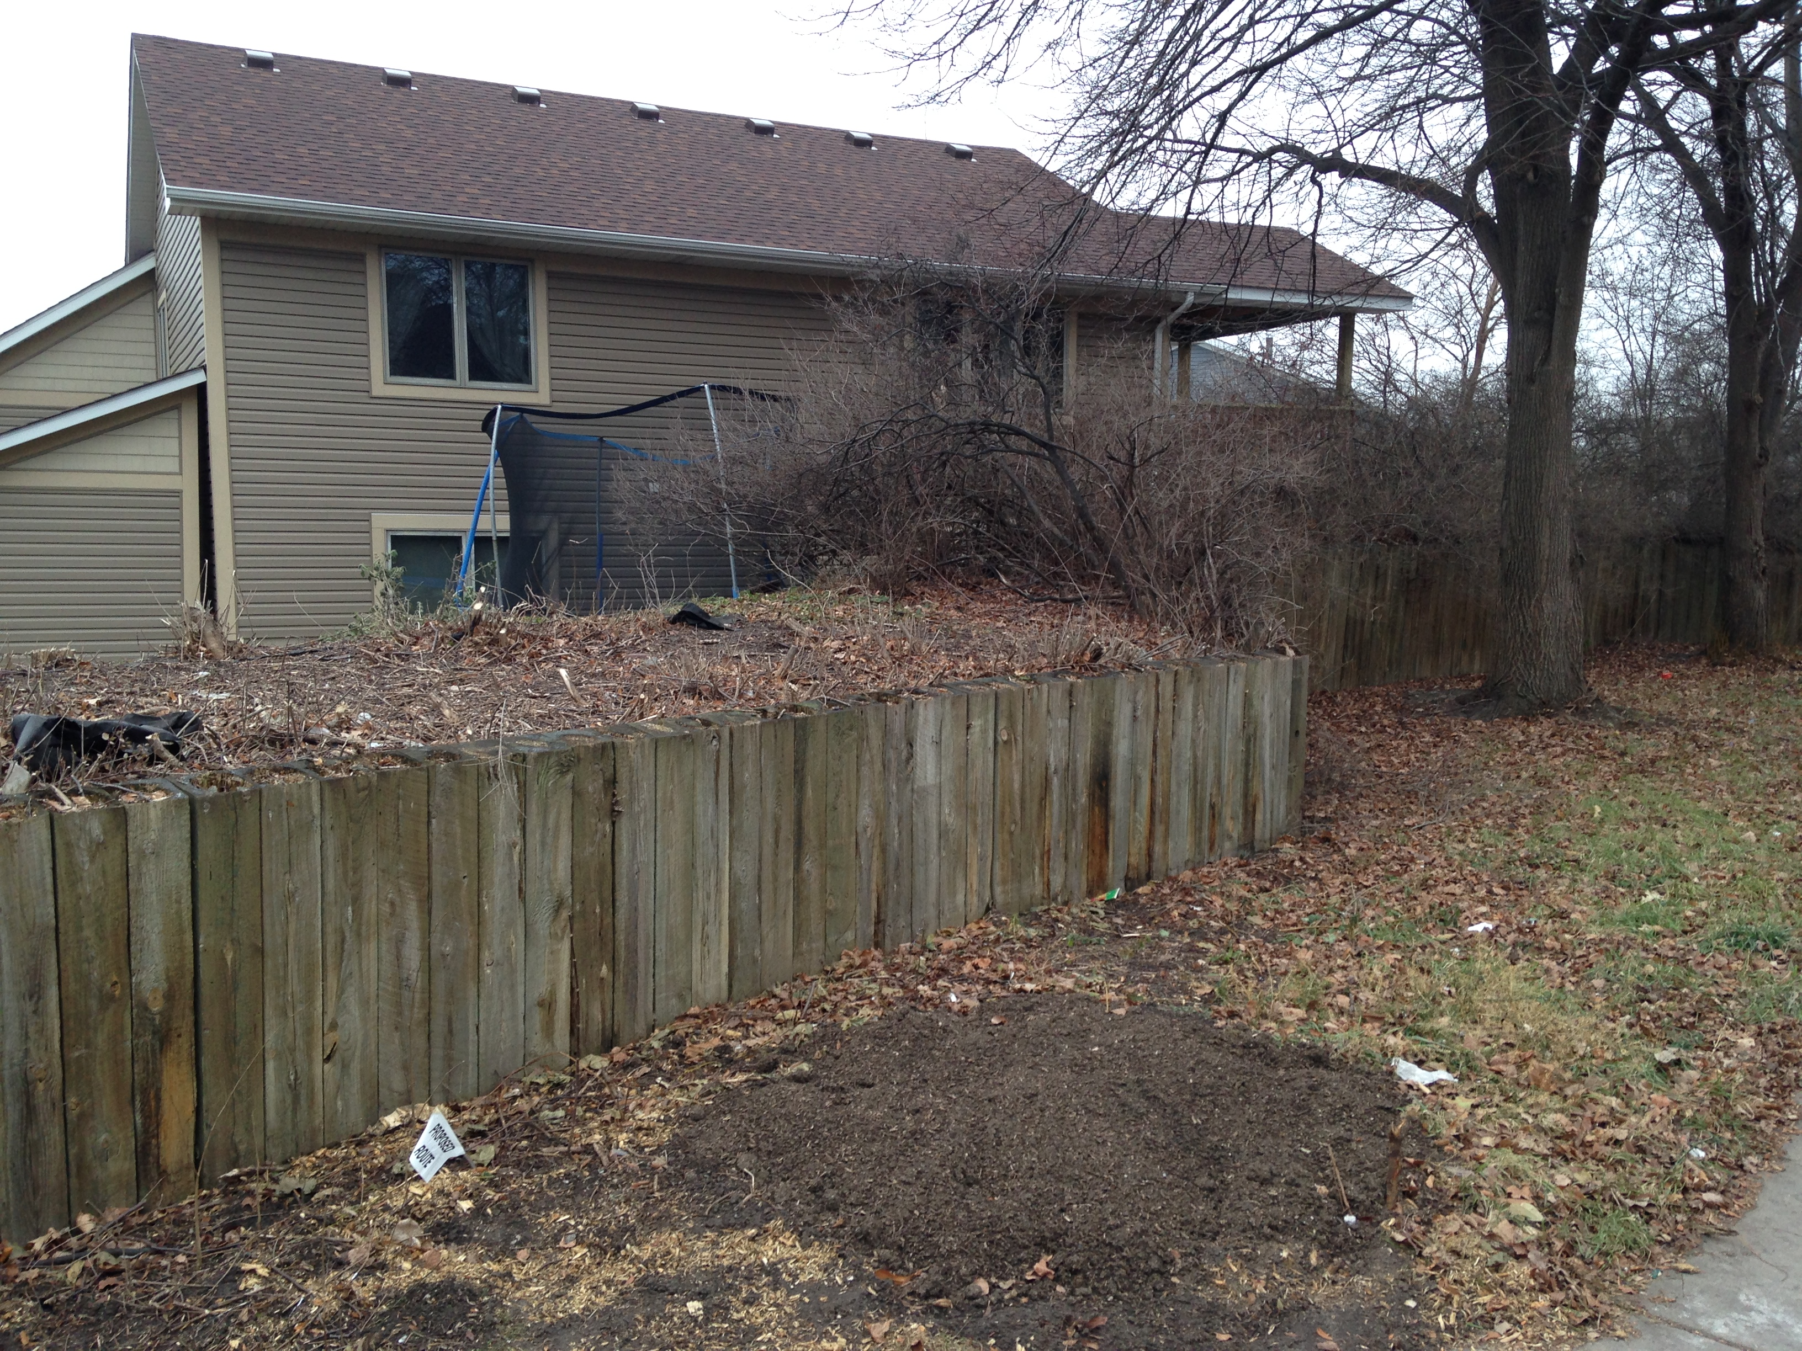
Even though it is still a bit chilly, the vivacious Sano and compassionate Russel are already starting to think about how they will get their kids out to play this spring and summer. Although most of their children have grown up and have moved on to college, their North Minneapolis house is still thriving with foster children, daycare children, and children in crisis. They have been foster parents since 2001, caring for children in the community for various periods of times.

Unfortunately, early last fall a tree destroyed the thick landscaping that insulated their back yard from a busy adjacent city street. In order for Sano and Russel to continue hosting children at their home, a fence needs to be built to create a safe space for the children to play, learn and grow, together. Rebuilding Together wants to keep this family safe by building a fence, but they need your help!

Let’s make sure that Sano and Russel can continue to care for children for years to come in their home.

This spring, we ask that you help us ensure that great people like Sano and Russel can continue doing amazing things for our community! Help us reach our goal of $4,000 by donating $50 to make sure that we’re able to help keep children safe in North Minneapolis. Thank you in advance for your support!

With Gratitude,

Your Signature Here

